Design of Experiments

Project 2: 3D Printed Beam Analysis

12/12/2017

Nick Bealo

Kris Fargo

Erik Gustafson

Brad Olsen

**Abstract:**

**Methods and Materials:**

**Results:**

The beam data was analyzed with respect to failure loads and respective masses. Actual by Predicted plots were created to show the fit of our model. All models were tested on two computers running SolidWorks optimization tests with similar mesh sizes (both meshes converged). This ensured the data had a good fit in the prediction plots. The failure load prediction plot had a good fit with all data points within the predictuion zones. Two data points in our analysis of the failure load test fell outside the bestfit line. The RMSE for the prediction was 28.614 due to this discrepency from the bestfit line, but it is a fairly well fit model. The prediction plot for beam mass had a very good fit with a RMSE of 0.3041. This is not surprising because the mass of the beams was calculated using the material properties from SolidWorks and automatically generated once beam dimensions were finalized. The p-value for both models was less than 0.001, meaning that the models both have good fits. Both Parameter Estimates tables for the Response Load and Mass have also been provided below. The most confident estimates for both are the dimensions A, C, and D in that order.

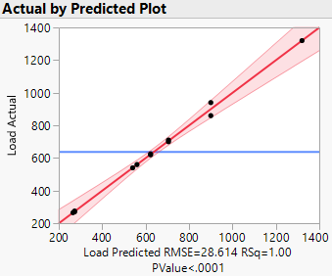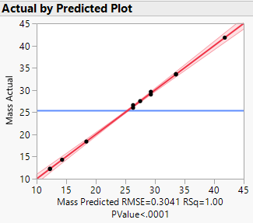

***Left Figure:*** *Load Actual by Predicted Plot.* ***Right Figure:*** *Mass Actual by Predicted Plot*

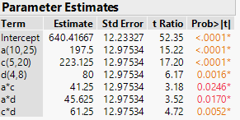 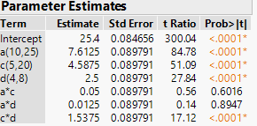

***Left Figure:*** *Parameter Estimates Response Load.* ***Right Figure:*** *Parameter Estimates Response Mass*

Using a least squares fit model of the experimental data an effect summary was created for the three factors. The two variables that effected the the value of the failure load were the beam width and the beam height. The p-values were zero for both and the LogWorth values were much higher than the next five parameters. The last source effect is not significant at a p-value of 0.05761 so it was removed from the model. This caused the third source effect, dimension d to become more significant with respect to the other sources effects.

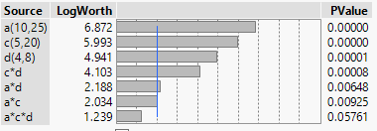

***Figure Above:*** *Dimensions Effect Summary*

**Confirmatory Trials:**

To confirm our prediction profilers estimated dimensions, three tests were run with specified predicted loads. The predicted dimensions for these loads were used to create the SolidWorks model to be tested. In the table below the values predicted by JMP are shown alongside the actual test results and the percent difference between the two. Although the actual loads were all greater than the predicted failure load, the percent difference between all tests was less than 11%. This error falls within the expected range given the failure modes of plastics.

|  |  |  |  |  |  |
| --- | --- | --- | --- | --- | --- |
| A | C | D | Predicted Load | Actual Load | % Difference |
| 23.598047 | 14.429789 | 4.9908041 | 800.00055 | 888 | 10.99992369 |
| 22.492686 | 12.698149 | 5.4908194 | 749.9995 | 802 | 6.933404622 |
| 14.638393 | 20 | 5.5021737 | 810.52281 | 824 | 1.662777387 |

***Table:*** *Confirmatory Trials, Predicted Failure Loads for Set Dimensions vs Actual Failure Load*

**Conclusion:**